Probability and Statistics
Assignment 01
Exploratory Data Analysis
(24L-0509)

The following document contains all the graphs and the statistics that have been obtained through the extensive use of python, plotting libraries (matplotlib) and (pandas) for numerical analysis.

Question 01
Initial Data Exploration:
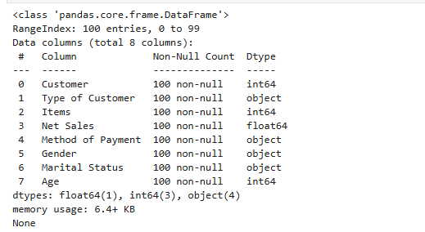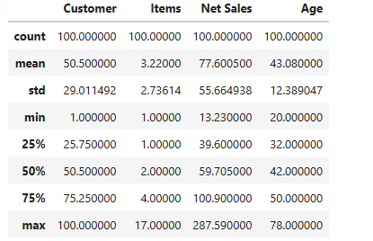

Global Descriptive Statistics:
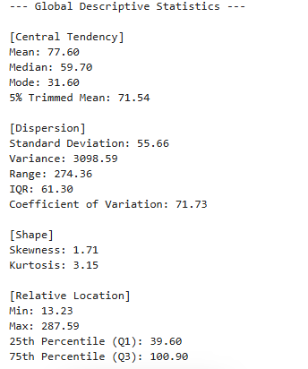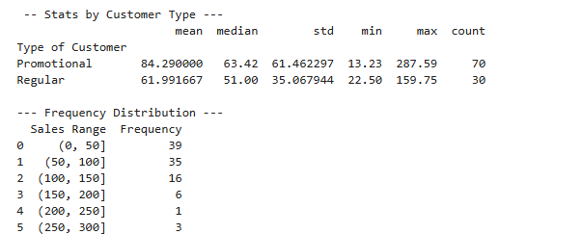

Histogram and Box Plot for the Net Sales vs the Customer Types
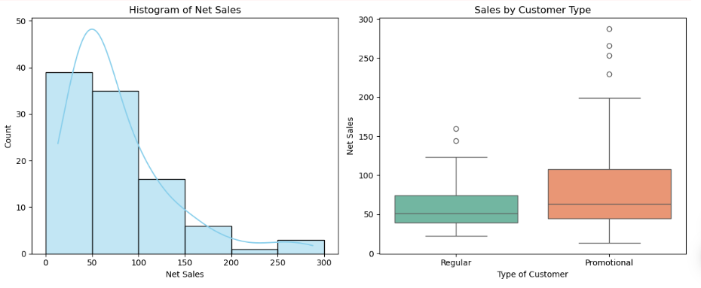

Question 2
Master Bi-variate Table: Age vs Net Sales
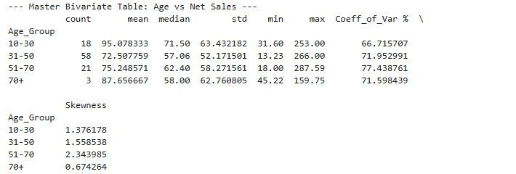

Numerical Relationship Metrics
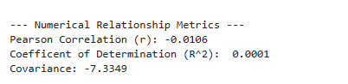
Scatter Plots and Violin Plot for the Categorization of Relationship and Distribution By Age

